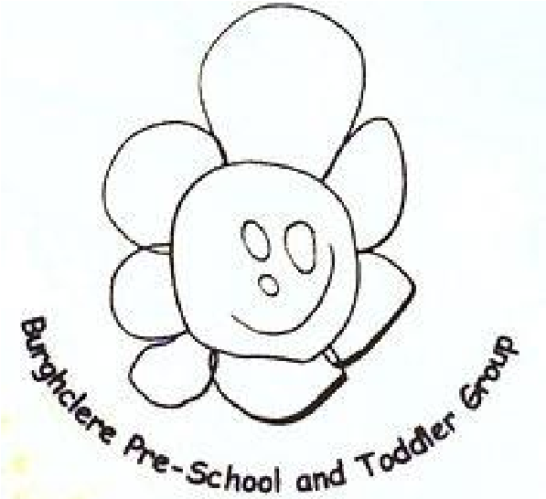
Christmas Update

2025

Burghclere Pre
-
School and Toddler Group

With Christmas fast approaching and everyone having so many exciting plans – I thought a quick update could be useful!

Reminder of Term Dates!

December 19th – last day of this term. (1pm finish)
Tuesday January 6th, 2026 – INSET DAY
Wednesday January 7th – First day back for spring term.
Half Term – Monday 16th – Friday 20th February.
Monday 23rd February – Back to pre-school.
Easter holidays – Monday 30th March – Friday 10th April

Monday 13th April – INSET DAY
Tuesday 14th April – Back to pre-school.

General Update
Sadly, Caitlin has decided to leave us at the end of this term as she is going to be joining her husband in his company. We will miss her but wish her all the best. We are actively looking for a new member of qualified staff to fill her shoes, so if you know of anyone in the childcare profession that maybe looking for a change of scenery, we have an advert on Indeed or get them to email me. This will be a full time role.
A big thank you to the parents that have come onto the committee, and we now have 11 people for this year, however next year we will be looking for the main 3 positions Chair, Secretary and Treasurer so please be aware that we will be calling you up.
The children will be doing lots of arts and crafts over the next few weeks so expect some glitter.

Christmas Jumper Day(s)

This is held on both Friday 12th and Friday 19th of December

Nativity Play and Raffle

We are holding our Nativity play on Friday 12th of December. All are welcome!
We will be starting between 9.15 to 9.30am, followed by a visit from Father Christmas and the raffle.
Children that do not normally attend a Friday session will need to be taken home after the festive activities.
Can you bring your children into Pre School for 9am if they do not normally attend that day.
We will provide outfits according to what your child will be in the play and if you can make sure, they are dressed in them when you bring them in (this is for ones that DON’T attend that day as a session). We will change the children that are in that day.

Christmas Party

We will be holding a Christmas party for ALL children on Friday 19th December.
If your child does not attend a Friday and you would like them to participate, please bring them in for 11am. We will have party games and a festive lunch so NO packed lunch boxes that day please – but please bring their drinks.
You can then collect them at 1pm.
We will be asking for food contributions towards the party, paper plates will be coming home with your child/ren the beginning of that week with their names on and what food we would like you to contribute.
Remember to wear Christmas jumpers!

Raffle Tickets

This year’s Christmas raffle will take place after the Christmas play on Friday 12th December. We are selling raffle tickets at £1.00 a ticket for some superb prizes. Please ensure all sold, unsold and money is in by Thursday 11th December.
We will have the all-time favourites of mince pies and refreshments.

School Photographer

He will be in on Friday 21st of November and your child’s photos will be ready before Christmas. If you would like your child photographed and they do not attend Fridays, please bring them in between the hours of 9.00am and 11am.



Don’t forget we close at 1pm on Friday 19th December and return Wednesday 7th January 2026

Best wishes Hayley, Clare, Juliann, Lesley, Amy, Sam and Caitlin.

