Burghclere pre-school, The Portal Hall, Church Lane, Burghclere, Newbury, Berks
Telephone 07749 316968
Burghclere Pre-school 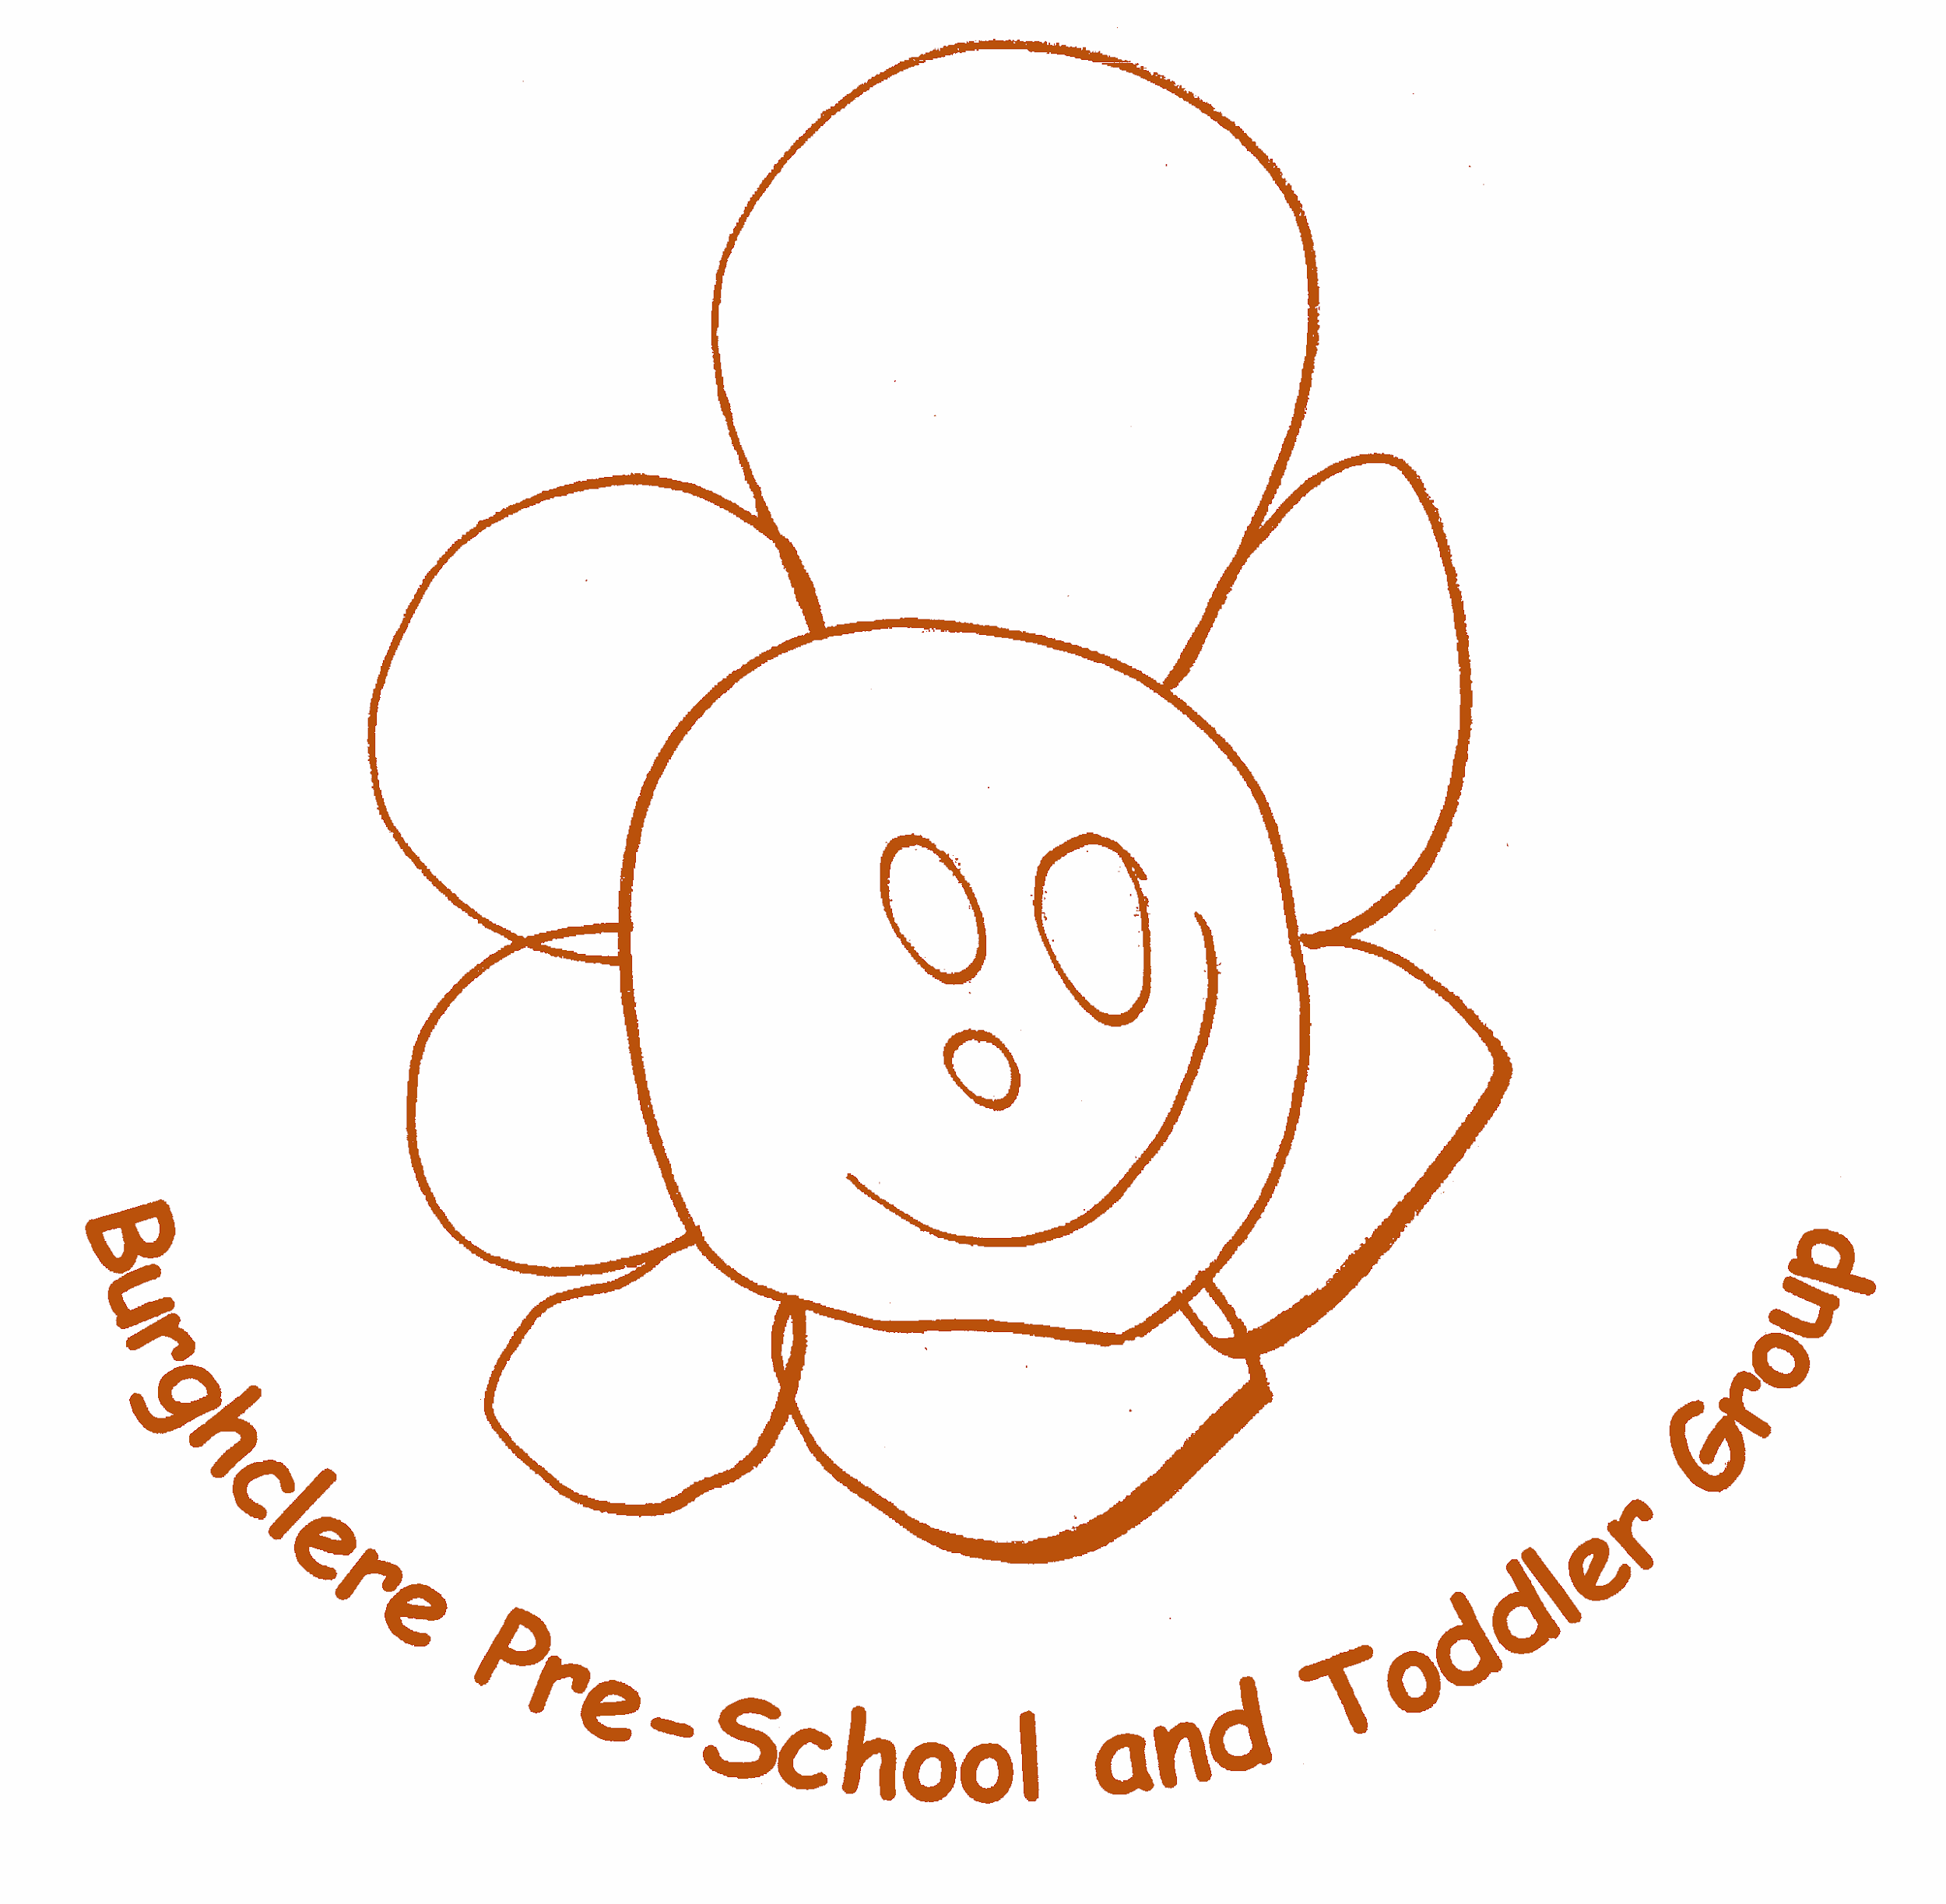
General Data Protection Regulation Policy
Statement
GDPR stands for General Data Protection Regulation and replaces the previous Data Protection
Directives that were in place. It was approved by the EU Parliament in 2016 and comes into effect on 25th May 2018
GDPR states that personal data should be ‘processed fairly & lawfully’ and ‘collected for specified, explicit and legitimate purposes’ and that individuals data is not processed without their knowledge and are only processed with their ‘explicit’ consent. GDPR covers personal data relating to individuals. Burghclere Pre-school is committed to protecting the rights and freedoms of individuals with respect to the processing of children's, parents, visitors and staff personal data.
The Data Protection Act gives individuals the right to know what information is held about them. It provides a framework to ensure that personal information is handled properly.
Burghclere Pre-school is registered with the ICO (Information Commissioners Office) under registration reference: A8381667. Certificates are on display on the parent’s information boards in the Pre-school.

GDPR includes 7 rights for individuals
1) The right to be informed
Burghclere Pre School is a registered Childcare provider with Ofsted and as so, is required to collect and manage certain data. We need to know parent’s names, addresses, telephone numbers, email addresses, date of birth and National Insurance numbers. We need to know the children's full names, addresses, date of birth and Birth Certificate number. For parents claiming the free nursery entitlement we are requested to provide this data to Hampshire County Council; this information is sent to the Local Authority via a secure electronic file transfer system. We are required to collect certain details of visitors to our pre-schools. We need to know visits names, times entered and left the premises and where appropriate company names are. This is in respect of our Health and Safety and Safeguarding Policies.

As an employer Burghclere Pre-school is required to hold data on its employees; names, addresses, email addresses, telephone numbers, date of birth, National Insurance numbers, photographic ID such as passport and driver’s license, bank details. This information is also required for Disclosure and Barring Service checks (DBS) and proof of eligibility to work in the UK. This information is sent via a secure file transfer system to UKCRBs for the processing of DBS checks.
Analytics, this data is anonymous.
2) The right of access
At any point an individual can make a request relating to their data and Burghclere Pre-school will need to provide a response (within 1 month). Burghclere Pre-school can refuse a request, if we have a lawful obligation to retain data i.e. from Ofsted in relation to the EYFS, but we will inform the individual of the reasons for the rejection. The individual will have the right to complain to the ICO if they are not happy with the decision.
3) The right to erasure
You have the right to request the deletion of your data where there is no compelling reason for its continued use. However Burghclere Pre-school has a legal duty to keep children’s and parents details for a reasonable time*, Burghclere Preschool retain these records for 3 years after leaving pre-school, children's accident and injury records for 19 years (or until the child reaches 21 years), and 22 years (or until the child reaches 24 years) for Child Protection records. Staff records must be kept for 6 years after the member leaves employment, before they can be erased. This data is archived securely offsite and shredded after the legal retention period.
4) The right to restrict processing
Parents, visitors and staff can object to Burghclere Pre-school processing their data. This means that records can be stored but must not be used in any way, for example reports or for communications.
5) The right to data portability
Burghclere Pre-school requires data to be transferred from one IT system to another; such as from Burghclere Pre-school to the Local Authority, to shared settings and to Tapestry' Online Learning Journal. These recipients use secure file transfer systems and have their own policies and procedures in place in relation to GDPR.
6) The right to object
Parents, visitors and staff can object to their data being used for certain activities like marketing or research.
7) The right not to be subject to automated decision-making including profiling. Automated decisions and profiling are used for marketing based organisations. Burghclere Preschool does not use personal data for such purposes. Storage and use of personal information. All paper copies of children's and staff records are kept in a locked office in Burghclere Pre-school and a locked filing cabinet. Members of staff can have access to these files but information taken from the files about individual children is confidential and apart from archiving, these records remain on site at all times. These records are shredded after the retention period.
Information about individual children is used in certain documents, such as, a weekly register, medication forms, referrals to external agencies and disclosure forms. These documents include data such as children's names, date of birth and sometimes address. These records are shredded after the relevant retention period.
Burghclere Pre-school collects a large amount of personal data every year including; names and addresses of those on the waiting list. These records are shredded if the child does not attend or added to the child’s file and stored appropriately.
Information regarding families’ involvement with other agencies is stored both electronically on an external hard drive and in paper format, this information is kept in a locked office and Burghclere Pre-school These records are shredded after the relevant retention period.
Upon a child leaving Burghclere Pre-school and moving on to school or moving settings, data held on the child may be shared with the receiving school. Such information will be sent via the internal Hampshire County Council post service or via a secure file transfer system.
For children attending school outside Hampshire County Council the parent/carer will be given the data to deliver to the receiving school.
Burghclere Pre-school stores personal data held visually in photographs or video clips or as sound recordings, unless written consent has been obtained via the Model Release form. No names are Burghclere Pre-school social media sites.
Access to all Office computers and Tapestry Online Learning Journal is password protected. When a member of staff leaves the company these passwords are changed in line with this policy and our Safeguarding policy. Any portable data storage used to store personal data, e.g. USB memory stick, are password protected and/or stored in a locked filing cabinet.
Our Data Protection Officer is Hayley Lynch: Manager
GDPR means that Burghclere Pre-school must;
* Manage and process personal data properly
* Protect the individual’s rights to privacy
* Provide an individual with access to all personal information held on them
This Policy was adopted at a meeting at Burghclere Pre School in July 2018
Signed on behalf of Burghclere Pre-school
This policy was adopted at a meeting of | Burghclere pre school | name of setting
Held on | 25th April 2022 | (date)
Date to be reviewed | April 2023 | (date)
Signed on behalf of the management committee | Hayley
Name of signatory | Hayley Lynch
Role of signatory (e.g. chair/owner) | Manager

