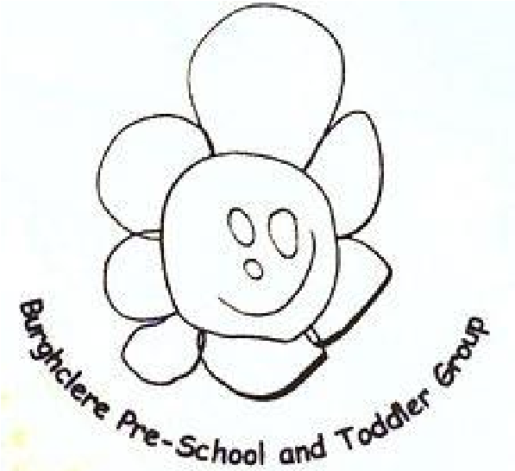

October 2024

Burghclere Pre
-
School and Toddler Group

What have we been doing?

We had a fantastic week with Halloween, the hall has been decorated with all spooky things. The children have looked fabulous throughout the week. All the staff even dressed up on the Friday (photo evidence on our Facebook page.)

Term Dates!

Half Term Monday 28th October – Friday 1st November
Inset Day Monday 4th November
End of Autumn Term Friday 20th December @ 1pm

Spring Term Tuesday 7th January 2025
Inset day Monday 6th January 2025

LUNCH BOXES
Allergies
We have children at the setting with severe NUT and EGG allergies, please DO NOT put anything with either of these into your child’s lunch boxes. Having either of these can cause a life threatening illness. E.G Chocolate spread, certain cereal bars.

ALL GRAPES AND MINI COCKTAIL SAUSAGES MUST BE CUT LENGTH WAYS IN HALF.

WE STILL HAVE GRAPES COMING INTO PRE SCHOOL NOT CUT LENGTHWAYS. THEY WILL BE TAKEN AWAY FROM YOUR CHILD.
THIS IS ONE OF THE EASIEST WAYS FOR YOUR CHILD TO CHOKE TO DEATH. CUT THEM LONG WAYS PLEASE!
5 MINUTES OF YOUR TIME IN THE MORNING IS NOTHING COMPARED TO WHAT THE OUTCOME COULD BE FOR YOUR CHILD!!!!!

School Sweatshirts and T-Shirts
We have a lovely selection of pre-school sweatshirts and t-shirts in a range of colours!
The sizes are aged 3-4 & aged 5 -6.
The sweatshirts are £9.00 and the t-shirts are £6.50.
This is a fantastic way of protecting your child’s favourite clothes, we do have messy play and at some point they may get paint, mud etc on their clothes. We hope that washing machines that get it all out but we can’t guarantee anything!

Christmas Nativity Play
The date for our Christmas Nativity Play and Raffle is Friday the 13th of December. The nativity will start from 9.15am followed by Father Christmas and our Raffle. More information will follow.

Committee News

We are always looking for more helpers on the committee. Please have a think about what skills you could bring to the committee.

This is your chance to get involved with what happens within your child’s pre-school and support the staff with lots of good ideas.

General News

Sadley Lindsay left to pursue another pathway, but we have recruited a lady called Emma who will start on Tuesday the 5th of November.

We are always looking for Bank Staff so if you know of anyone that maybe interested, please point them this way. They do not have to be qualified.
(Bank Staff consists of being available at very short notice and can be very ADHOC.)

Please can I remind you that the pre-school doors do not open until 9am unless you have requested the early start sessions (cost £1.50 Per Day.) We staff these in accordance with ratios and therefore cannot take any children in that have not registered for this, unless this has been agreed beforehand not on the morning.
Please let me know if this is something you would be interested in. The earliest start is 8.45am due to insurance.

We must have the Christmas Cards pictures back to us by the week ending the 8th of November at the very latest, these only need to be given back if you have ordered anything, and the orders need to be made and paid for online. Just follow the instructions of the form.

The school photographer is coming out on Friday 22nd of November, if your child does not attend that day but you would like their photo taken, please pop in between 9am and 11am.

Have a good half term and we will see you on Tuesday the 5th ready for Bonfire Night.

From the Burghclere team – Hayley & All The Staff xx

