Promoting health and hygiene

1.18 No-smoking (including the use of e-cigarettes/vaping)

Policy statement

Burghclere Pre-School complies with health and safety regulations and the Welfare Requirements of the EYFS in making our setting a no-smoking environment - both indoor and outdoor.

EYFS key themes and commitments

A Unique Child | Positive Relationships | Enabling Environments | Learning and Development
1.4 Health and well-being | 2.1 Respecting each other | 3.2 Supporting every child

Procedures

- All staff, parents and volunteers are made aware of our no-smoking policy.
- We display no-smoking signs.
- The no-smoking policy is stated in our information brochure for parents.
- We actively encourage no-smoking by having information for parents and staff about where to get help to stop smoking if they are seeking this information.
- If staff smoke, they may do so during working hours whilst on a break, but they are asked to leave the premises.
- Staff who smoke during their break make every effort to reduce the effect of the odour and lingering effects of passive smoking for children and colleagues, by taking this into the open air.

Legal framework

- The Smoke-free (Premises and Enforcement) Regulations 2006
www.opsi.gov.uk/si/si2006/20063368.htm
- The Smoke-free (Signs) Regulations 2007
www.opsi.gov.uk/si/si2007/20070923.htm

This policy was adopted at a meeting of | Burghclere Pre-School
Held on | 30th April 2025 | (date)
Date to be reviewed | April 2026 | (date)
Signed on behalf of the management committee | 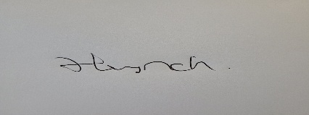
Name of signatory | Hayley Lynch
Role of signatory (e.g. chair/owner) | Manager

