Safeguarding children

1.9 Maintaining children’s safety and security on premises

Policy statement

Burghclere Pre-School maintains the highest possible security of our premises to ensure that each child is safely cared for during their time with us.

EYFS key themes and commitments

A Unique Child | Positive Relationships | Enabling Environments | Learning and Development
1.3 Keeping safe | 2.2 Parents as partners

Procedures

Children's personal safety
- Burghclere Pre-School ensures all employed staff have been checked for criminal records by an enhanced disclosure from the DBS (disclosure and barring service.)
- Adults do not normally supervise children on their own.
- All children are supervised by adults at all times.
- Whenever children are on the premises at least two adults are present.
- Burghclere Pre-School carry out risk assessment to ensure children are not made vulnerable within any part of our premises, nor by any activity.

Security
- Systems are in place for the safe arrival and departure of children.
- The times of the children's arrivals and departures are recorded.
- The arrival and departure times of adults - staff, volunteers and visitors - are recorded.
- Our systems prevent unauthorised access to our premises.
- Our systems prevent children from leaving our premises unnoticed.
- The personal possessions of staff and volunteers are securely stored during sessions.

This policy was adopted at a meeting of | Burghclere Preschool | name of setting
Held on | 30th April 25 | (date)
Date to be reviewed | April 2026 | (date)
Signed on behalf of the management committee | 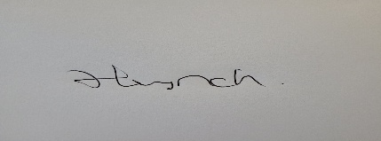
Name of signatory | Hayley Lynch
Role of signatory (e.g. chair/owner) | Manager

