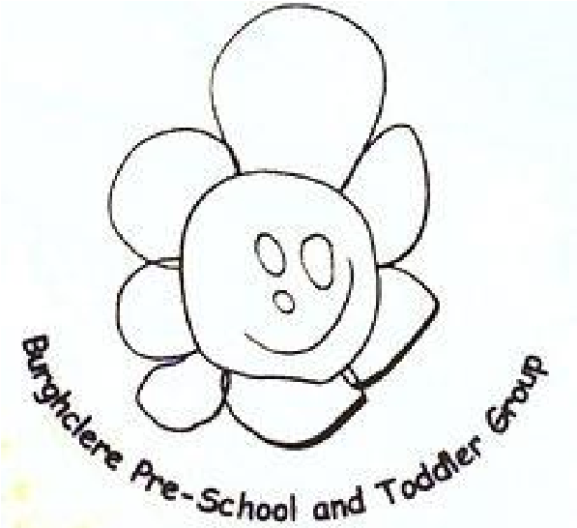

October 2025

Burghclere Pre
-
School and Toddler Group

What have we been doing?

Welcome to all the new children and families. We have spent the last few weeks settling the children in and getting them use to their new surroundings.

They have started to learn our days of the week song and understand our daily routine.

Term Dates!

Autumn Term
Inset day Wednesday the 3rd of September
Term starts Thursday 4th of September
Half Term Monday 27th of October – Friday 31st of October.
Inset Day Monday the 3rd of November.
Christmas Break Friday 19th Of December @ 1pm
Inset day Monday 5th January 2026
Term Starts Tuesday 6th January 2026
Half Term Monday 16th February – Friday 20th February 2026
Easter Holidays Friday 27th March 2026

LUNCH BOXES
Allergies
We have children at the setting with severe NUT & EGG allergies, please DO NOT put anything with Nuts or Eggs into your child’s lunch boxes. These can cause a life-threatening illness. E.G Chocolate spread, certain cereal bars, egg sandwiches.

ALL GRAPES AND MINI COCKTAIL SAUSAGES MUST BE CUT LENGTH WAYS IN HALF. GRAPES MUST BE CUT AGAIN IN HALF.

WE STILL HAVE GRAPES COMING INTO PRE SCHOOL-NOT CUT LENGTHWAYS AND AGAIN IN HALF. THEY WILL BE TAKEN AWAY FROM YOUR CHILD.
THIS IS ONE OF THE EASIEST WAYS FOR YOUR CHILD TO CHOKE TO DEATH. CUT THEM LONG WAYS AND IN HALF AGAIN PLEASE!
5 MINUTES OF YOUR TIME IN THE MORNING IS NOTHING COMPARED TO WHAT THE OUTCOME COULD BE FOR YOUR CHILD!!!!!

Did you know that most lunch boxes can go in your washing machine to get rid of any germs that they may have got over the week.
Give it a try and you will be surprised.

School Sweatshirts and T-Shirts
We have a lovely selection of pre-school sweatshirts and t-shirts in a range of colours!
The sizes are aged 3-4 & aged 5 -6.
The sweatshirts are £9.00 and the t-shirts are £6.50.
This is a fantastic way of protecting your child’s favourite clothes, we do have messy play and at some point they may get paint, mud etc on their clothes. We hope that washing machines that get it all out but we can’t guarantee anything!

AGM Meeting

We have our annual AGM (Annual General Meeting) on Thursday 23rd of October being held in the club room of the portal hall.
Time 8pm.
Why should I attend? This is your child’s pre school and your chance to find out what goes on behind the scenes. You can make a difference.
What are the roles? We are looking for various roles to be filled.

The pre school can not operate without a full committee so please come along and find out if you can help. It will close if the committee roles are not filled.

Tapestry

I have sent out links to everyone to click on to be able to access your child’s learning journey.
Please check your junk folders, this is a lovely way for you to see what your child has been doing whilst in our care… So what are you waiting for if you have not already signed up go and sign up.

Please also keep an eye out for messages or accident forms that may have been uploaded. We upload accident forms if your child is not collected by a parent or carer.

Pick up

Can we just ask at 3pm pick up can you wait outside the building please as it can get very cramped in the small hallway and I would be worried that a child may get past the adult without being seen if there are so many bodies in one small space.

Reporting Sickness

Can we request that you text us regarding your child’s absence from pre-school.

If the illness is sickness and diarrhoea, please ensure you keep them off for 48hours from the last bout of sickness.

If your child needs calpol etc should they be in pre-school? The best place for them is at home.

Halloween

Halloween is during the October half term this year, so if your child would like to dress up any day (or everyday) the week starting the 20th then please let them come to pre-school in their scariest costumes.

Staff will spook you all on the Friday.


This Photo by Unknown Author is licensed under CC BY-NC

From the Burghclere team – Hayley & All the Staff xx

