Employment
1.22 Induction of staff, volunteers and managers
Policy Statement
Burghclere Pre-School provides an induction for all staff, volunteers and managers in order to fully brief them about the setting, the families we serve, our policies and procedures, curriculum and daily practice.

EYFS key themes and commitments

A Unique Child | Positive Relationships | Enabling Environments | Learning and Development
1.3 Keeping safe | 2.4 Key person | 3.2 Supporting every child

Procedures
- Burghclere Pre-School has a written induction plan for all new staff, which includes the following:
- Introductions to all staff and volunteers, including all management committee members.
  - Familiarisation with the building, health and safety and fire procedures.
  - Ensuring our policies and procedures have been read, understood and executed.
  - Introduction to parents, especially parents of allocated key children where appropriate.
- Familiarising them with confidential information where applicable in relation to any key children.
- Details of the tasks and daily routines to be completed.
- The induction period lasts two weeks. The manager inducts new staff and volunteers. The chairperson inducts new managers.
- During the induction period the individual must demonstrate understanding of and compliance with policies, procedures, tasks and routines.
- Successful completion of the induction forms part of the probationary period of six months with regular reviews. This procedure is managed and documented by the Pre-School Manager.

This policy was adopted at a meeting of | Burghclere Pre-School
Held on | 30th April 2025 | (date)
Date to be reviewed | April 202 | (date)
Signed on behalf of the management committee | 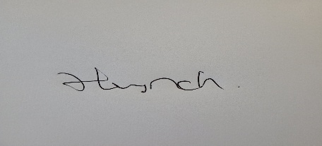
Name of signatory | Hayley Lynch
Role of signatory (e.g. chair/owner) | Manager

Other useful Early years Learning Alliance publications

- Employment in Early Years Settings (2007)

