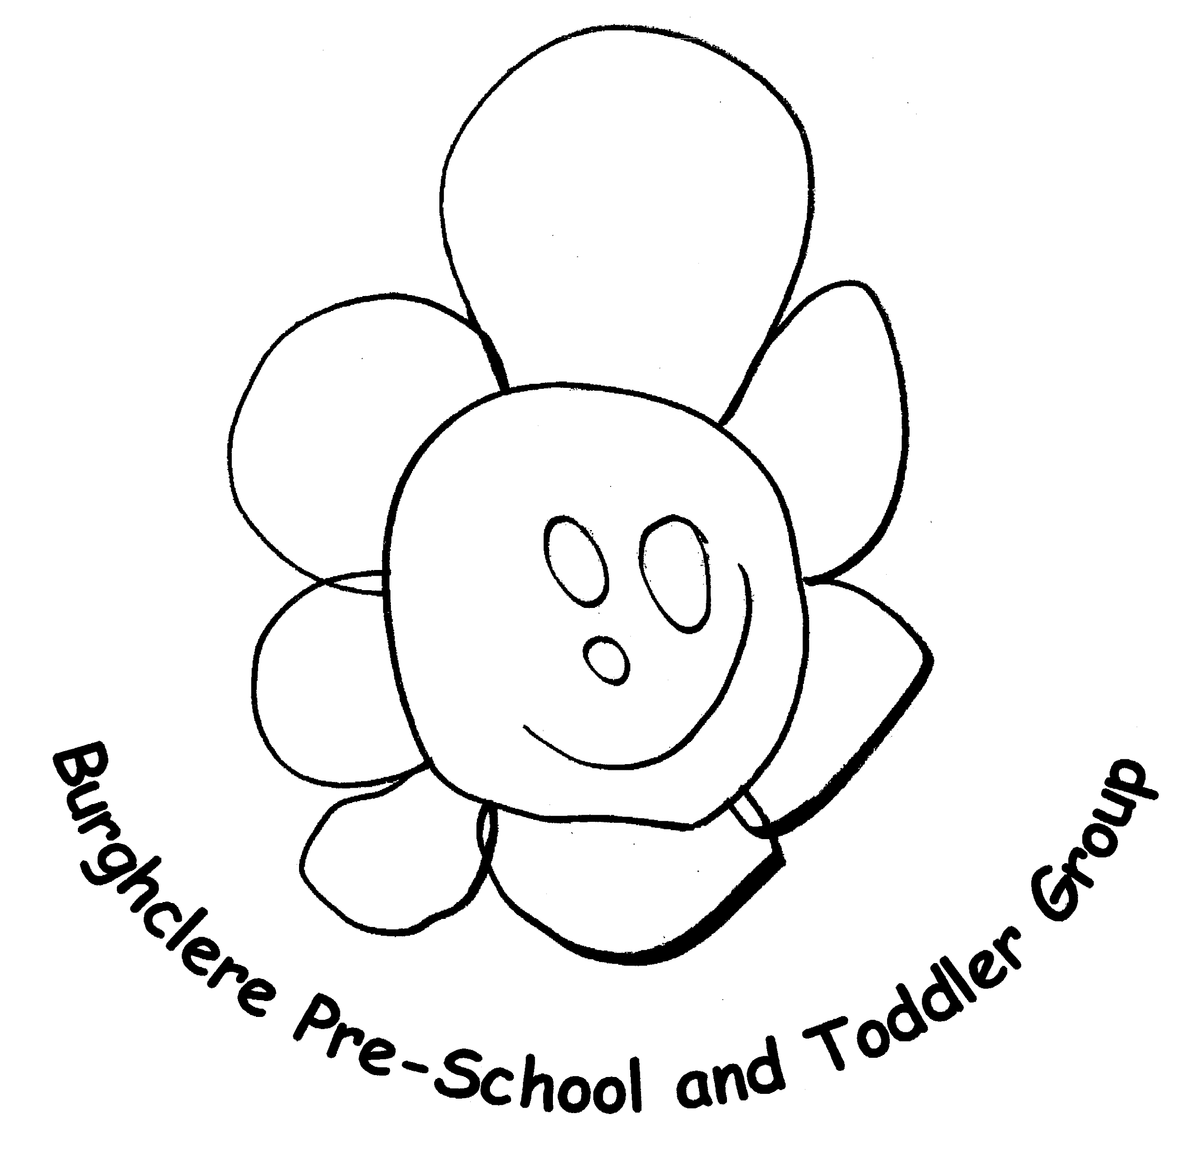
Outbreak Management Plan for
Burghclere Pre School
1.39

Introduction
This plan is based on the contingency framework for managing local outbreaks of COVID-19, provided by the Department for Education (DfE).
We implement measures in this plan in response to recommendations provided by our local authority (LA), the director of public health (DPH), Public Health England (PHE) our local health protection teams or by following government guidance.
These measures will be implemented to help prevent the spread of infection within the nursery settings, to manage a COVID-19 outbreak or cluster, to react to high COVID-19 infection rates in the community or when all measures in place are still failing to reduce risk and infection.
It is important that everyone complies with the latest Government guidance on Coronavirus. Compassionate leadership is at the heart of offering continued pre-school care and we will do everything we can to be honest, open and to communicate with you. There will be a lot of anxieties and we acknowledge that it is okay to feel worried and that COVID-19 and the lockdown has had an impact on everyone. Everyone involved in the day to day running of the pre-school will receive appropriate instruction and training on how to operate safely.

Measures to prevent the spread of infection
Since the start of the coronavirus pandemic, we have been pleased with our Safe Operating Procedures and the adaptations we have made to our everyday practice to ensure we offered, and continue to offer, our staff and children a safe environment. Hygiene is the main key elements of infection prevention and control. We have made the decision to keep the following procedures in place
- Any child, staff member, parent or visitor with coronavirus symptoms must use their own judgement to decide if they need to stay at home.
- Children will not be accepted into pre-school if they have been given fever reducing medication, at parent’s discretion, Children with temperatures cannot return until they have been 24 hours fever free, without the need of medication to assist.
- Increased cleaning processes remain in place.
- Ventilation is a key part of infection control, doors and windows remain open and outdoor play is encouraged.
- All persons travelling outside of the UK must adhere to instructions and testing in line with the country they are travelling to government guidance.

Management of an Outbreak of COVID-19 in the setting
When the pre-school infection cases of children or staff members reach 10% in a setting over a 14 day period this may be referred to as a COVID-19 outbreak. Burghclere pre-school will take further advice from PHE. Actions may be:
- A more intense deep clean
- Restrictions of people entering the building
- Partial closure of areas in the pre school
- Isolation of identified children or staff members
- Investigation by the LA Health Protection Team

Management of a Cluster in a pre-school setting
When there are increased infection cases of children or staff members setting over a 14-day period this may be referred to as a COVID-19 cluster. Burghclere pre-school will take further advice from PHE. The actions we will take are:
- Look at the possible need to close the group
- As current guidance does not request that preschool settings to isolate, we are instructing all staff members connected with a positive case to take Lateral Flow tests for 7 days
- Burghclere pre-school use their extended staff teams to ensure legal ratios continue to be met
- There will remain a Safeguarding Lead, Named First Aider and Named Manager or deputy on site at all times.

Reaction to high infection rates in the local community
Burghclere pre-school ensure that they are up to date with infection records. If contacted by DsPH or the LA regarding a high level of infection in the local community the following actions may be recommended:
- Events and social days at the pre-school are delayed
- Visitors are not permitted onto the setting site unless essential to a child’s development or well-being or to manage an essential need (ie. site maintenance). Any visitors that are permitted on site must wear a face mask and give their details to allow pre-school to manage contact tracing if needed.
Actions following high levels of risk and infection
Attendance restrictions will only be used as a last resort. Our requests would be presented in the following order:
- If you are able to keep your child home to please do so.
- Only vulnerable children and those whose parents are critical workers may attend.
- Only vulnerable children and those with both parents as critical workers may attend.

Burghclere preschool wish to remain transparent in all proposed actions and advice that we receive from any of the above-mentioned professionals. We thank you for adhering to our Safe Operating Procedures and Risk Assessments and for taking the time to read this Outbreak Management Plan.
If you have any questions you can always contact Hayley on admin@burghclerepreschool.co.uk Updated May 2022

This policy was adopted at a meeting of | Burghclere Pre School | name of setting
Held on |  | (date)
Date to be reviewed | April 2026 | (date)

Signed on behalf of the management committee
Name of signatory | Lucy Nelligan
Role of signatory (e.g. chair/owner) | Trustee

